**Regain Stroke Rehabilitation**

Video Catalogue

The following catalogue is intended as a simple visual reference guide to each of the 32 stroke rehabilitation videos, filmed this far for the Regain project. Each video is listed in order (1-32), indexed by four referents: a still image (1), a numeric identifier/exercise name (2), a brief description of content (3), and a meta-data tag (4).

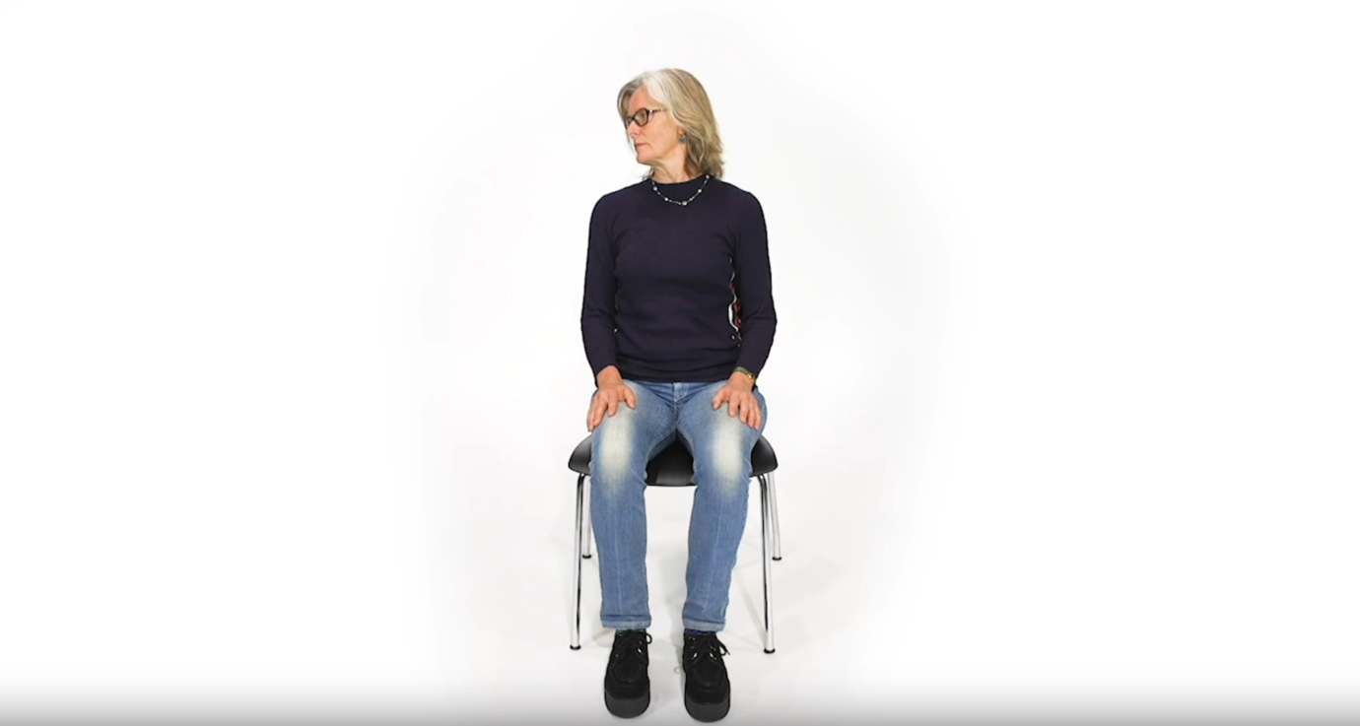

1. Figure 1 above

2. 01_NeckRoll

3. Patient rolls neck from left to right and back again.

4. 01

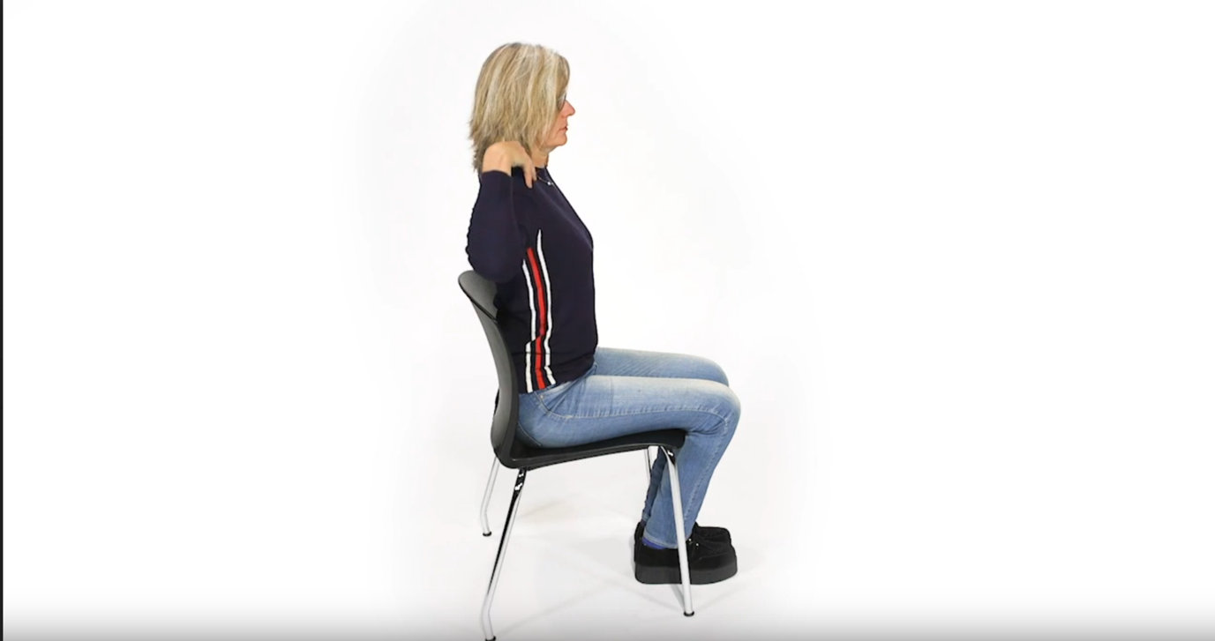

1. Figure 2 above

2. 02_ShoulderCircles

3. Patient rolls shoulder from forward to back position.

4. 02

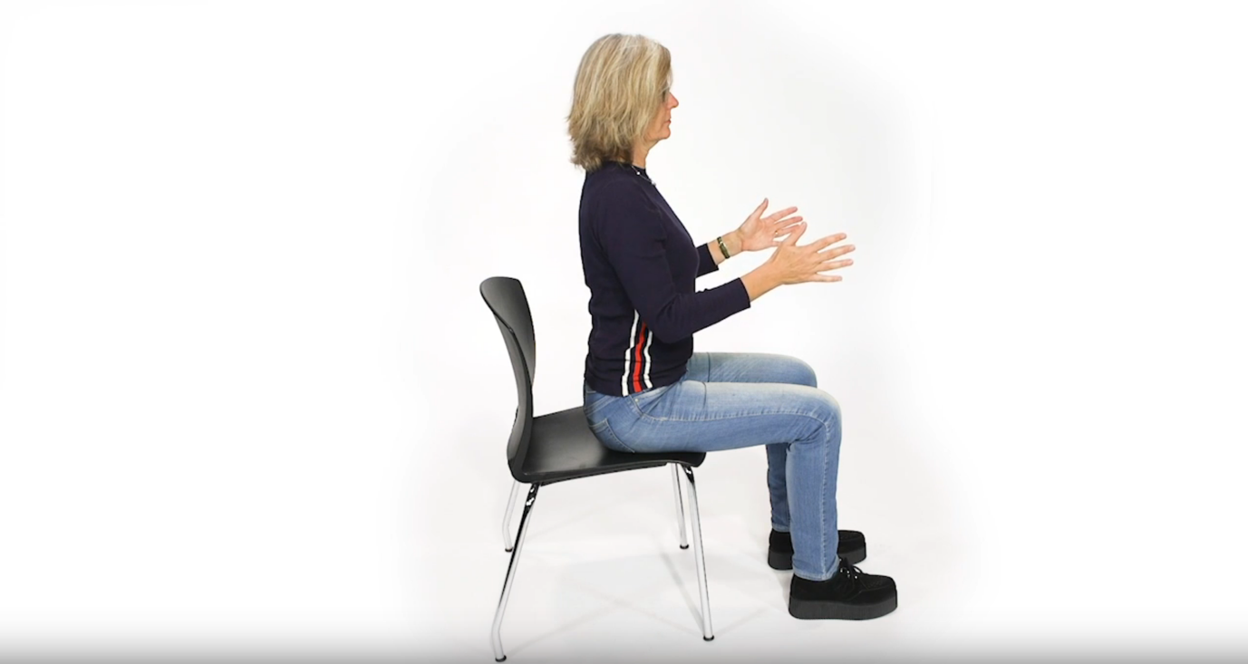

1. Figure 3 above

2. 03_SeatedRow

3. Patient moves both arms in ‘mock rowing’ exercise.

4. 03

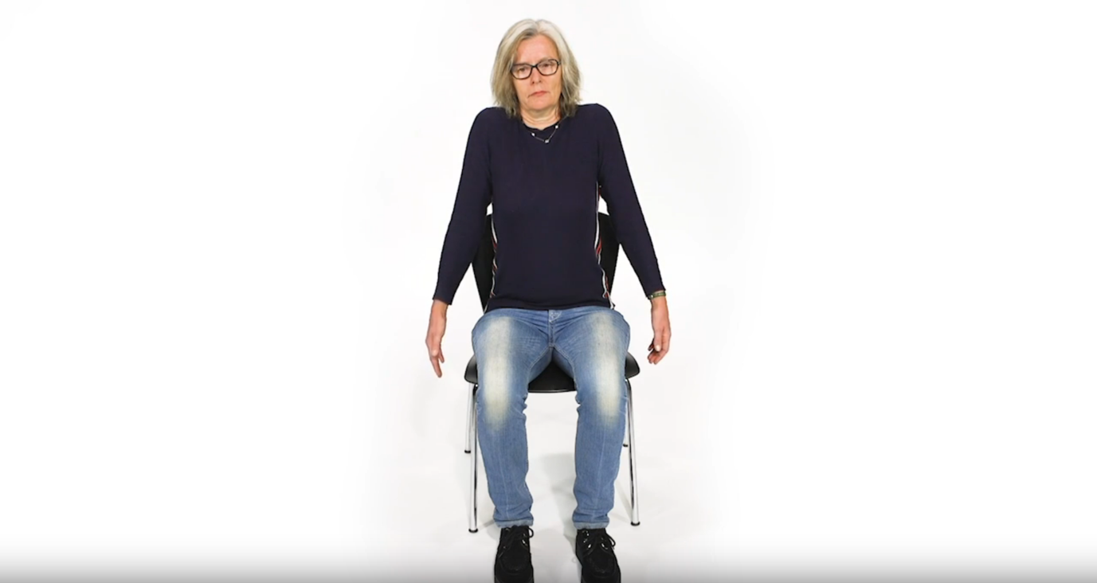

1. Figure 4 above

2. 04_ShoulderRolls

3. Patient rolls both shoulders forward and back.

4. 04

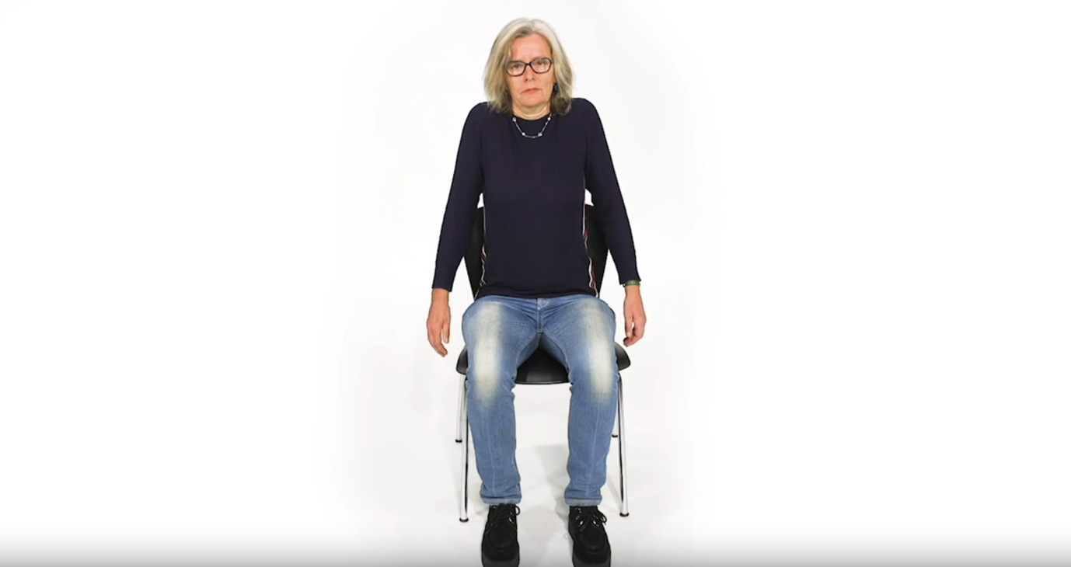

1. Figure 5 above

2. 05_ShoulderShrugs

3. Similar to 04 with more of a vertical shrug movement. Patient shrugs shoulders in unison.

4. 05

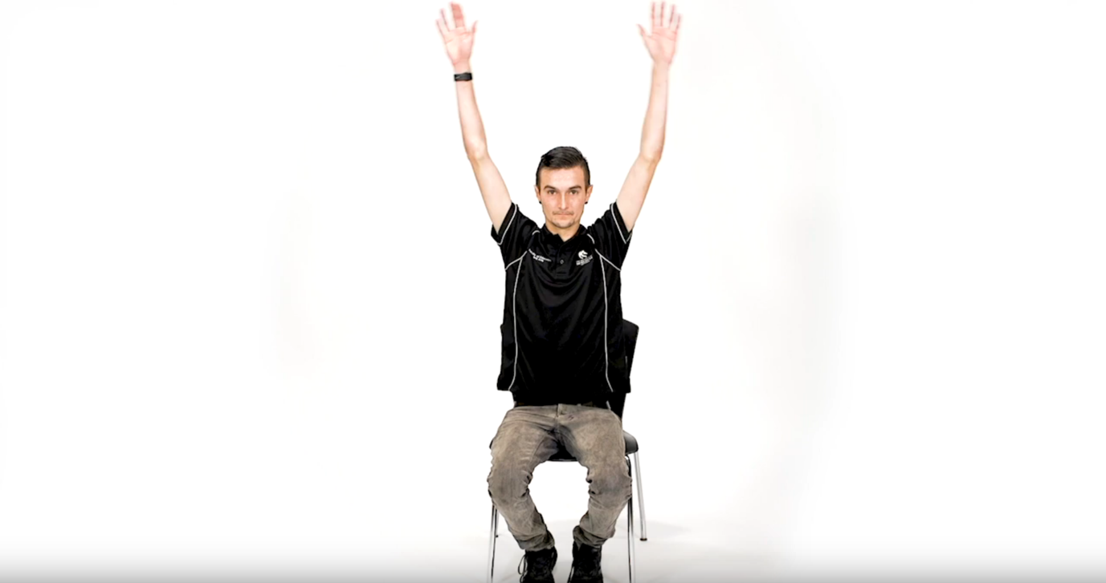

1. Figure 6 above

2. 06_SeatedJumpingJacks

3. Similar to a jumping jack, with only upper body movement.

4. 06

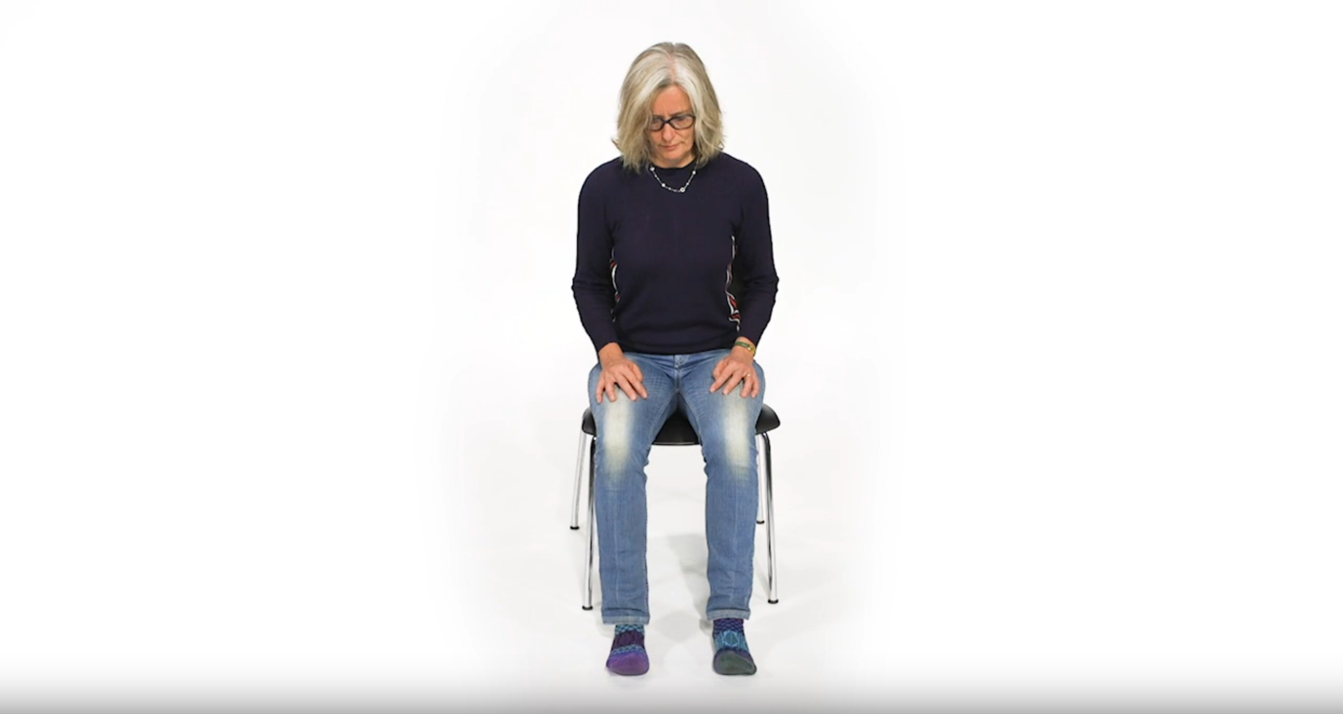

1. Figure 7 above

2. 07_ToeTaps

3. Patient slowly raises toes from seated position, one after the other, then lowers.

4. 07

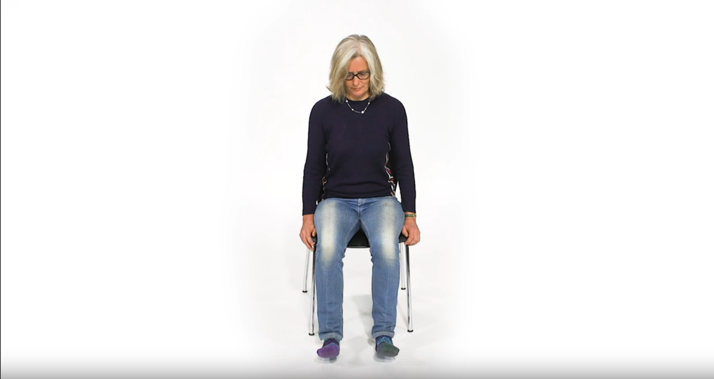

1. Figure 8 above

2. 08_ToeTapsVariation

3. Variation to 07. Patient slowly raises toes in unison from seated position, then lowers.

4. 08

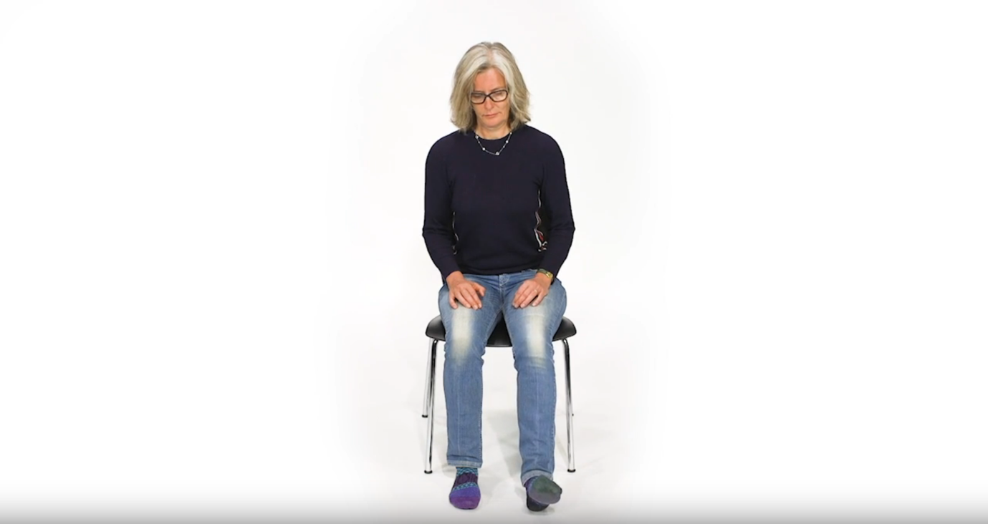

1. Figure 9 above

2. 09_HeelSlides

3. Patient slowly slides each heel from seated position, one after the other.

4. 09

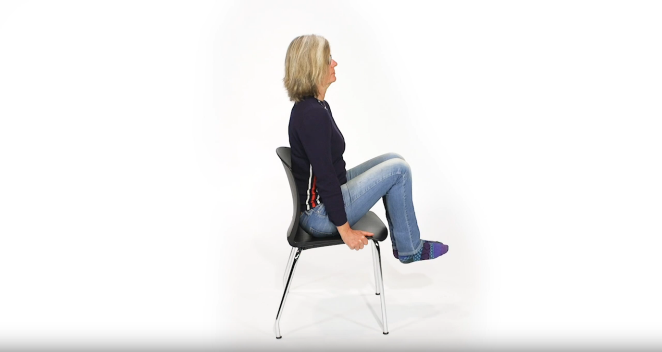

1. Figure 10 above

2. 10_ CaptainsChair

3. Patient holds chair with both hands, ready to take their weight. From seated position, slowly raises legs in unison toward a 90 degree angle.

4. 10

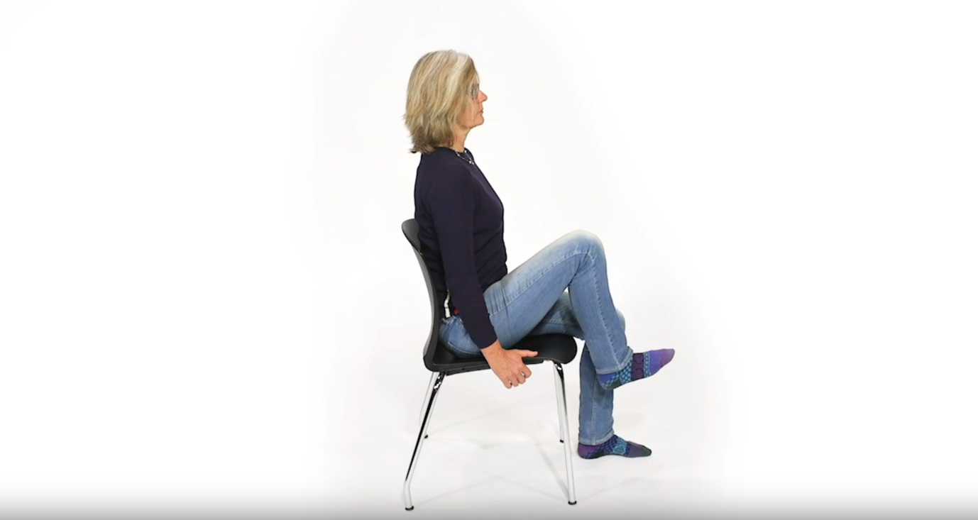

1. Figure 11 above

2. 11_KneeLifts

3. Patient slowly raises each knee to their chest from seated position, one after the other.

4. 11

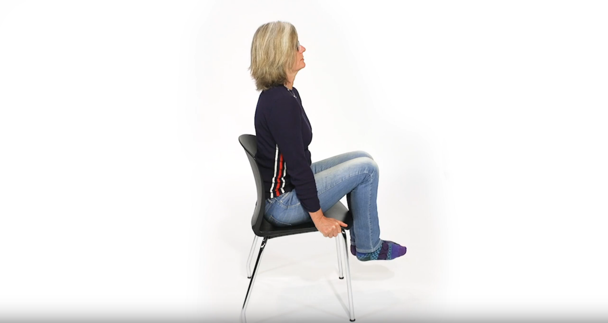

1. Figure 12 above

2. 12_ModifiedLegLifts

3. Patient slowly raises both knees to their chest from seated position, in unison.

4. 12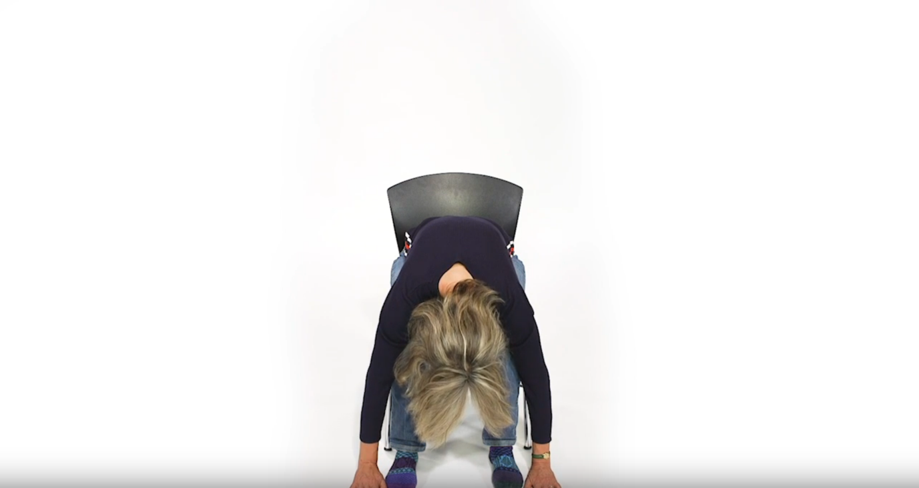

1. Figure 13 above

2. 13_SeatedForwardBend

3. Patient slowly leans forward from seated position, to touch the floor with both hands in unison.

4. 13

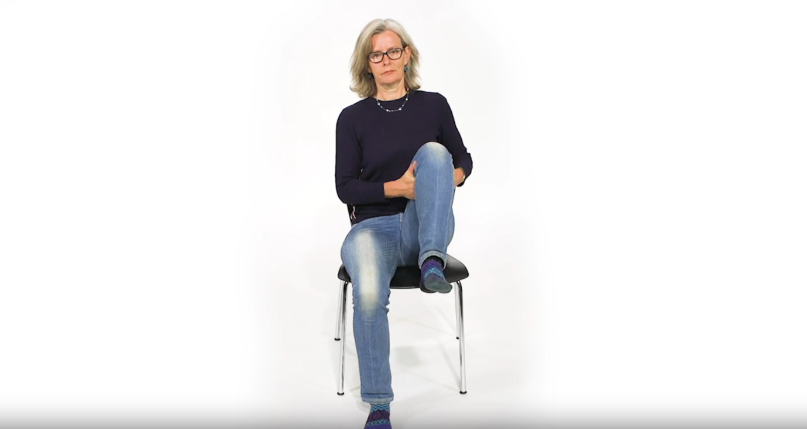

1. Figure 14 above

2. 14_KneetoChest

3. Patient slowly raises each knee to their chest from seated position.

4. 14

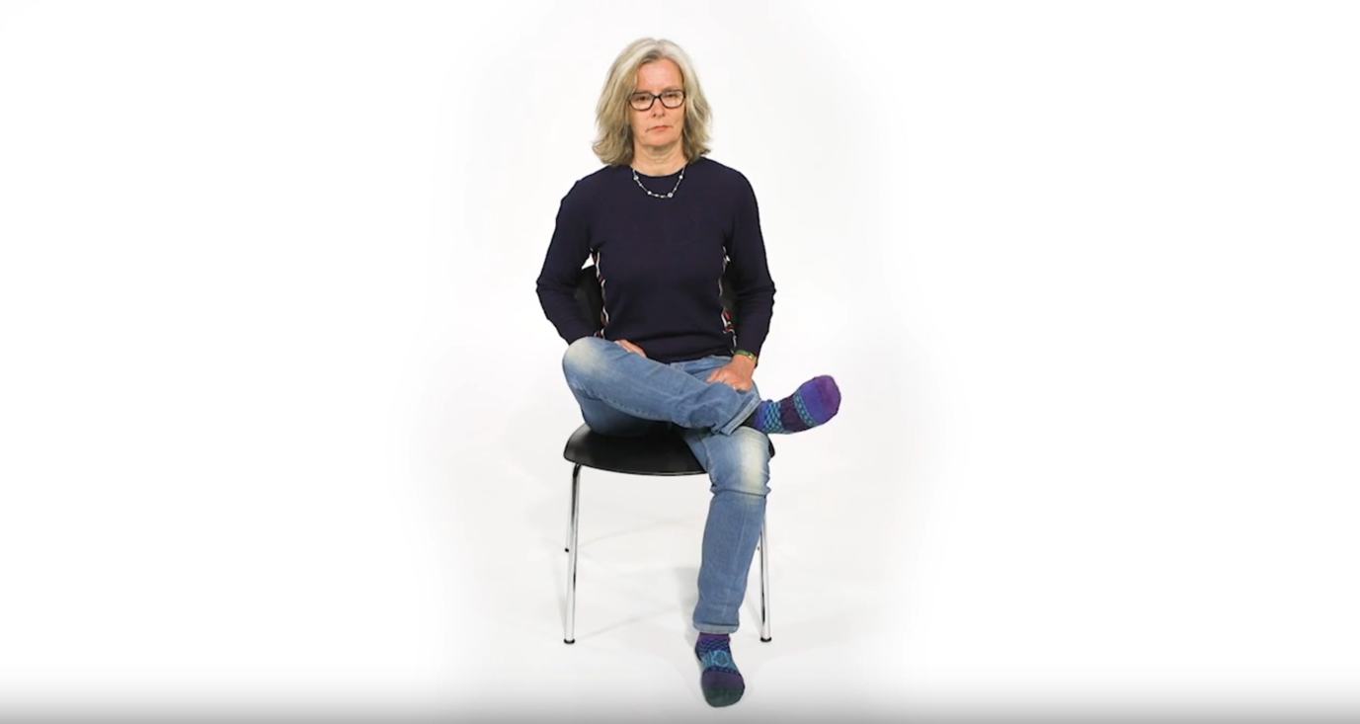

1. Figure 15 above

2. 15_AnkleRotation

3. Patient places right outer ankle on left knee from seated position, before slowly rotating ankle. Repeat for each leg.

4. 15

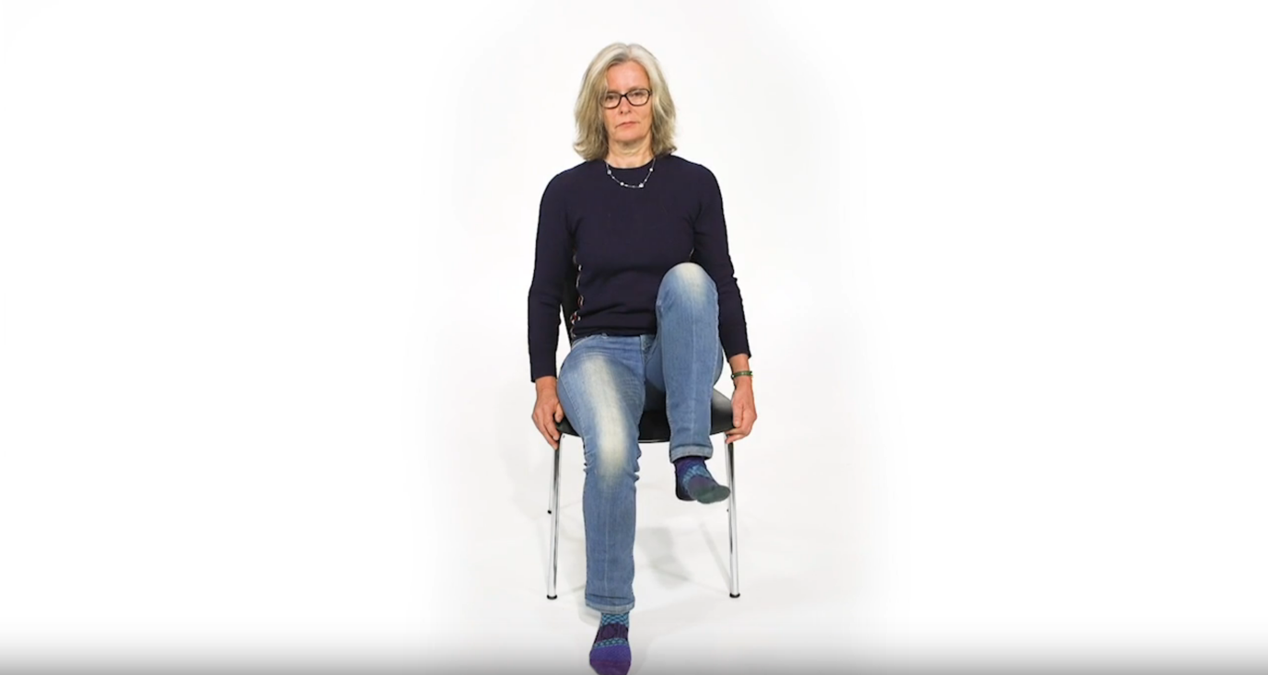

1. Figure 16 above

2. 16_SeatedHipMarches

3. Patient raises each leg, one after the other from seated position, in a mock ‘marching’ action.

4. 16

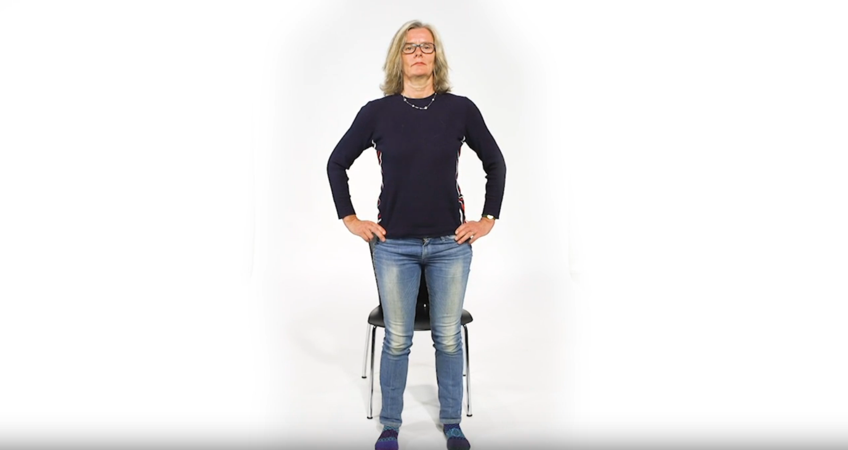

1. Figure 17 above

2. 17_SitToStand

3. Patient begins from seated position, to slowly stand, supporting both hips with hands as they move.

4. 17

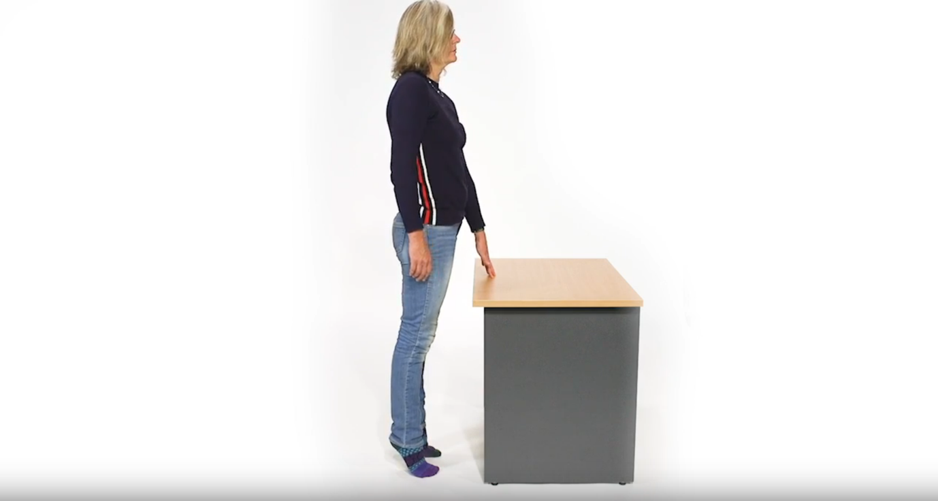

1. Figure 18 above

2. 18_HeelAndToeRaises

3. Patient begins from standing position, supported by a desk. Slowly move to a tiptoe position, weight balanced on ball of foot with heel raised.

4. 18

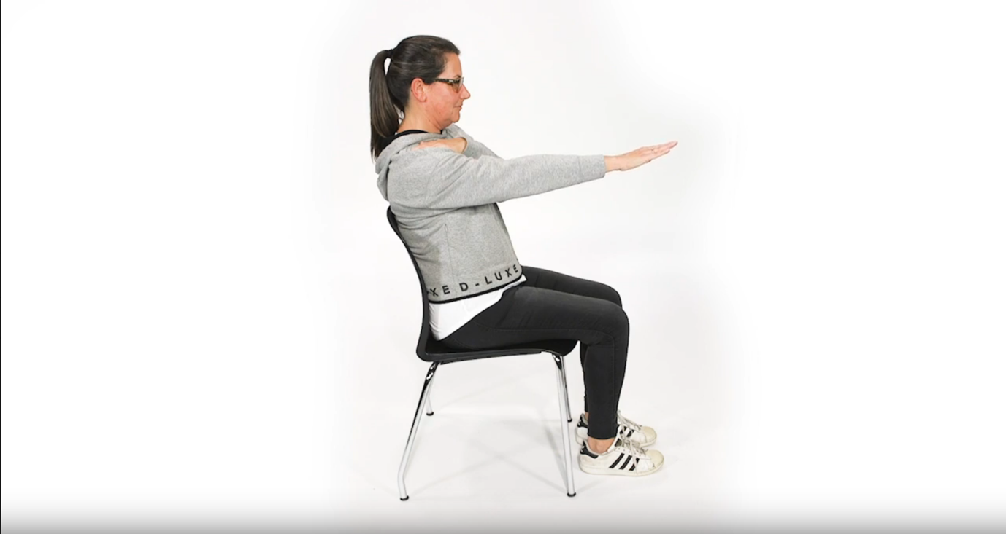

1. Figure 19 above

2. 19_ArmToFront

3. Patient begins from seated position. With left arm placed on right shoulder, raise right arm to the front, while outstretched. Then reverse position for left arm.

4. 19

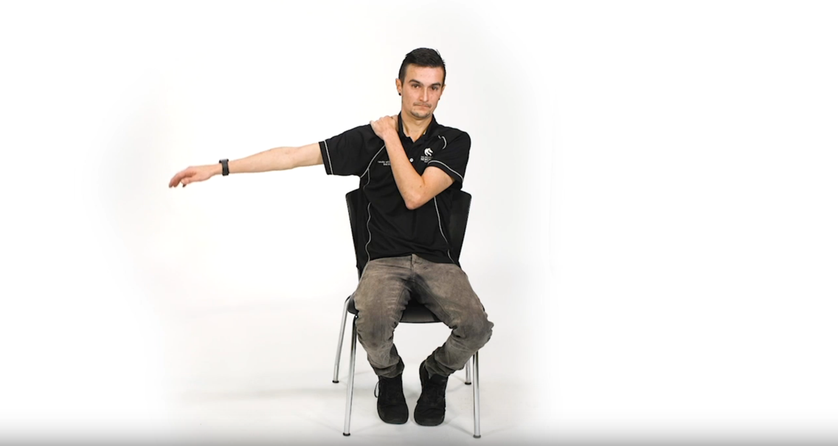

1. Figure 20 above

2. 20_ArmToSide

3. Patient begins from seated position. With left arm placed on right shoulder, raise right arm to the side, while outstretched. Then reverse position for left arm.

4. 20

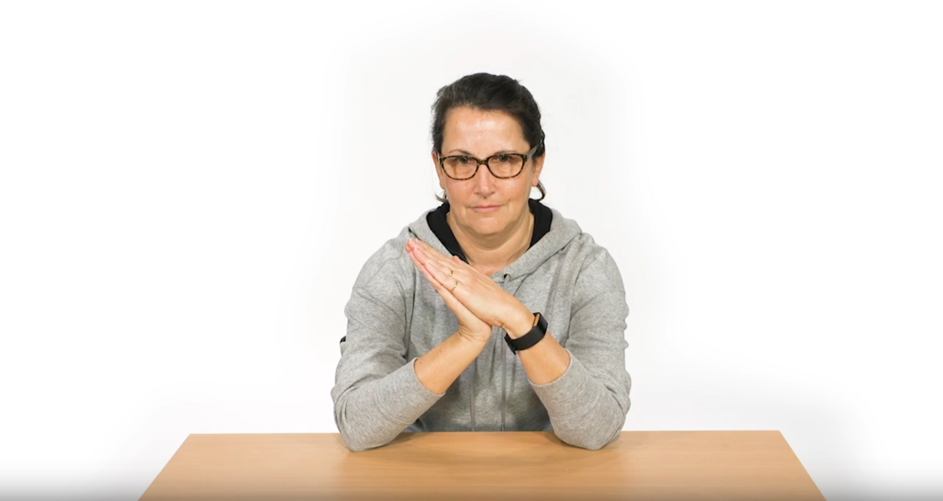

1. Figure 21 above

2. 21_HandAndWristStretch

3. Patient begins seated at desk. With both hands placed together so as to match, right hand exerts slow pressure on left hand. Then reverse direction of pressure for left hand.

4. 21

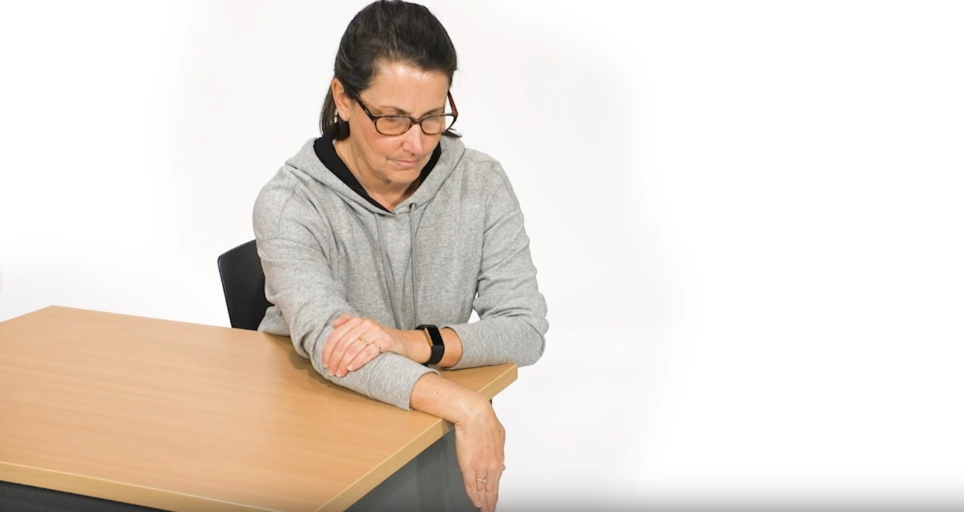

1. Figure 22 above

2. 22_WristStretch

3. Patient seated at desk. Right arm is extended so that right wrist can flex over end of desk, while left hand supports the right forearm. Then reverse exercise for left wrist.

4. 22

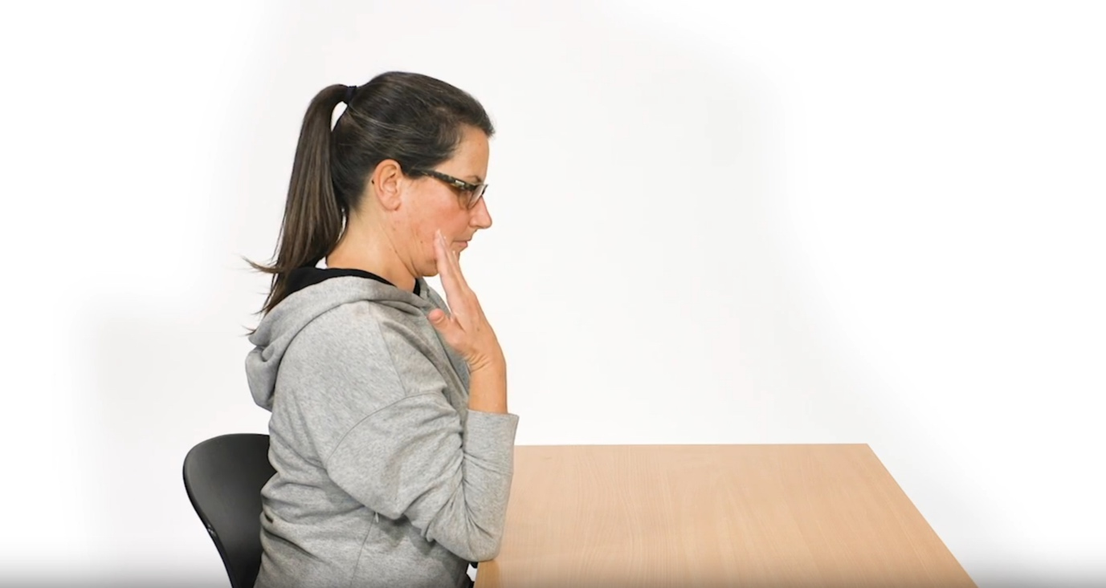

1. Figure 23 above

2. 23_ElbowStretch

3. Patient seated at desk with elbow rested on desk surface. Right arm gradually raised and lowered from/to shoulder position. Then reverse exercise for left arm.

4. 23

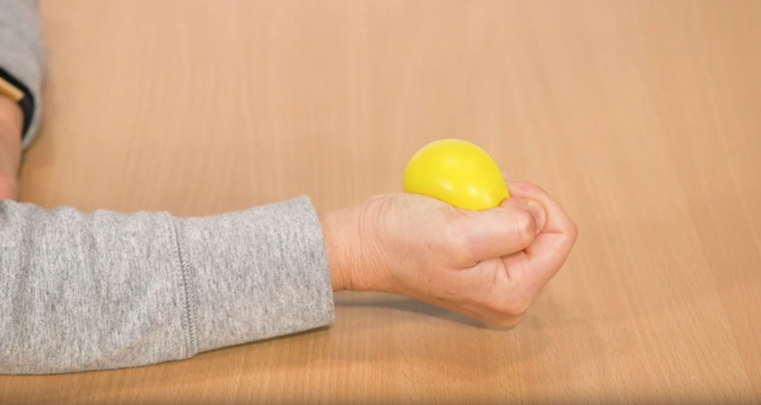

1. Figure 24 above

2. 24_Squeeze

3. Patient seated at desk with elbow and arm rested on desk surface. Right hand gradually squeezes a spongy ball. Then reverse exercise for left hand.

4. 24

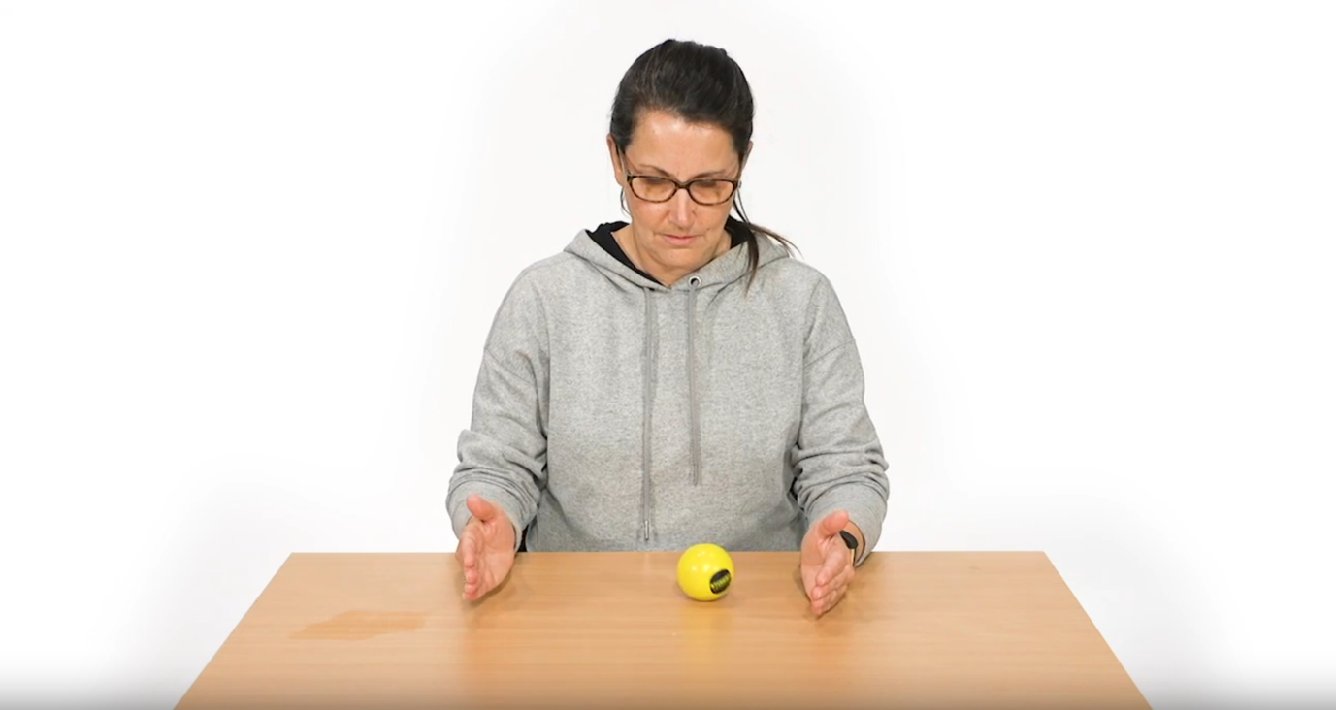

1. Figure 25 above

2. 25_BallRoll

3. Patient seated at desk with both hands facing one another, arms rested. Hands roll a ball back and forth.

4. 25

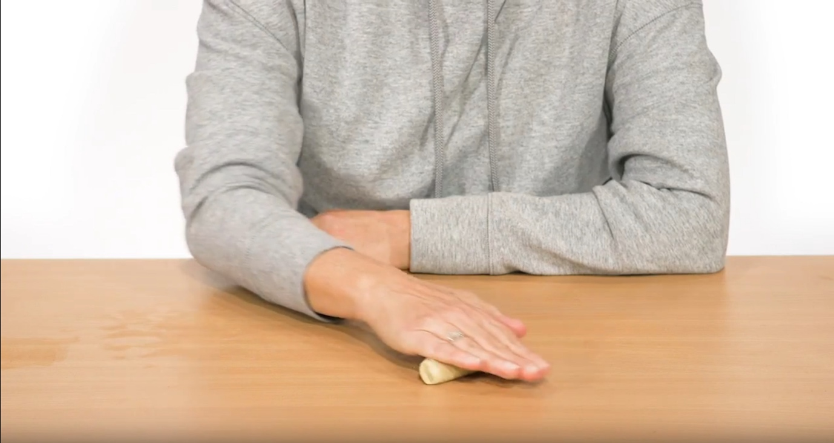

1. Figure 26 above

2. 26_FingerPower

3. Patient seated at desk with right hand rolling a slim oblong object, while left arm rests on desk for support. Reverse for left hand.

4. 26

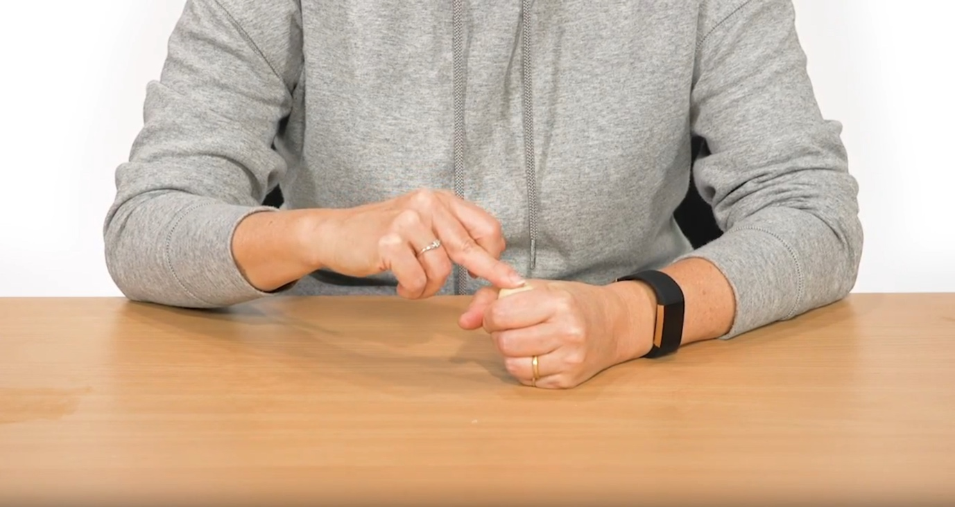

1. Figure 27 above

2. 27_FingerStrength

3. Patient seated at desk with left hand clenched, each finger on the right hand presses the clenched fist. Reverse the exercise.

4. 27

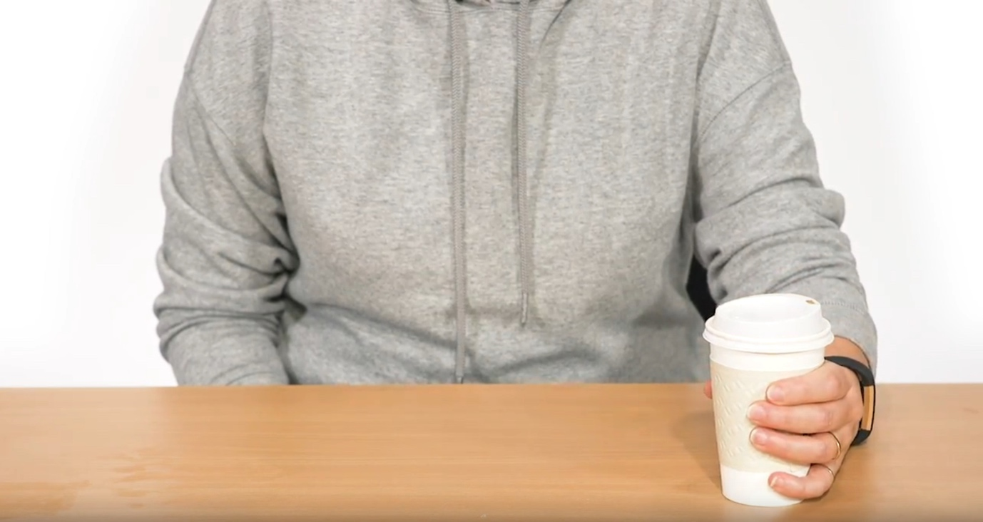

1. Figure 28 above

2. 28_Waiter_Cup

3. Patient seated at desk with left hand relaxed, then slowly grasps a cup. Reverse the exercise for right hand.

4. 28

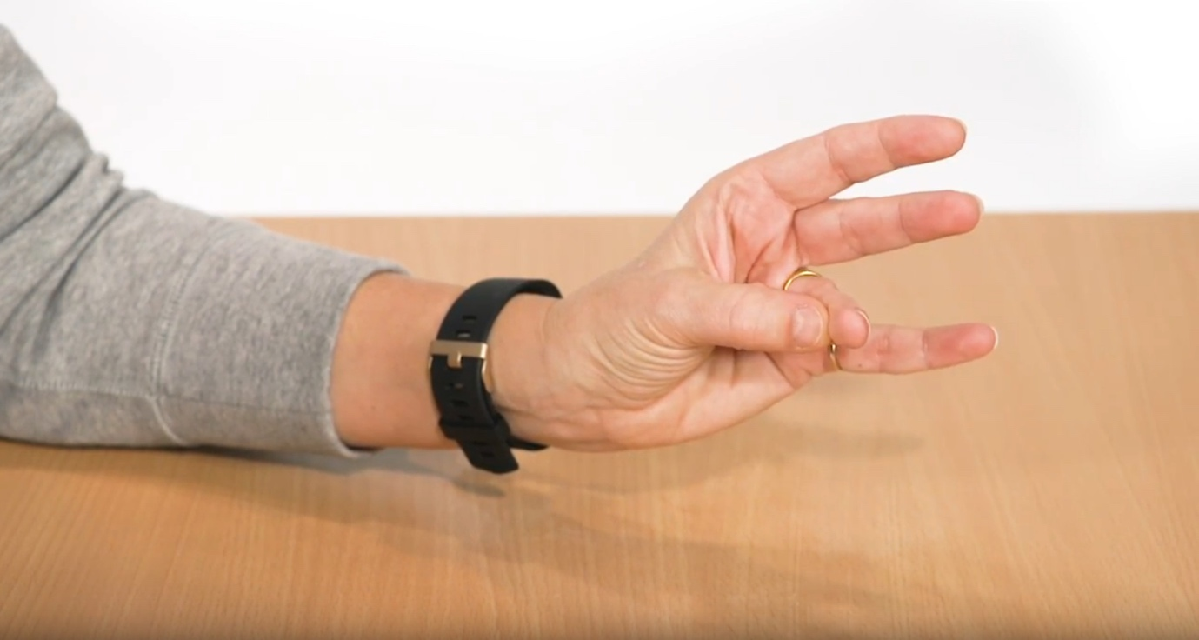

1. Figure 29 above

2. 29_FingertipToPalm

3. Patient seated at desk with left hand relaxed, then slowly bends each fingertip toward their palm. Reverse the exercise for right hand.

4. 29

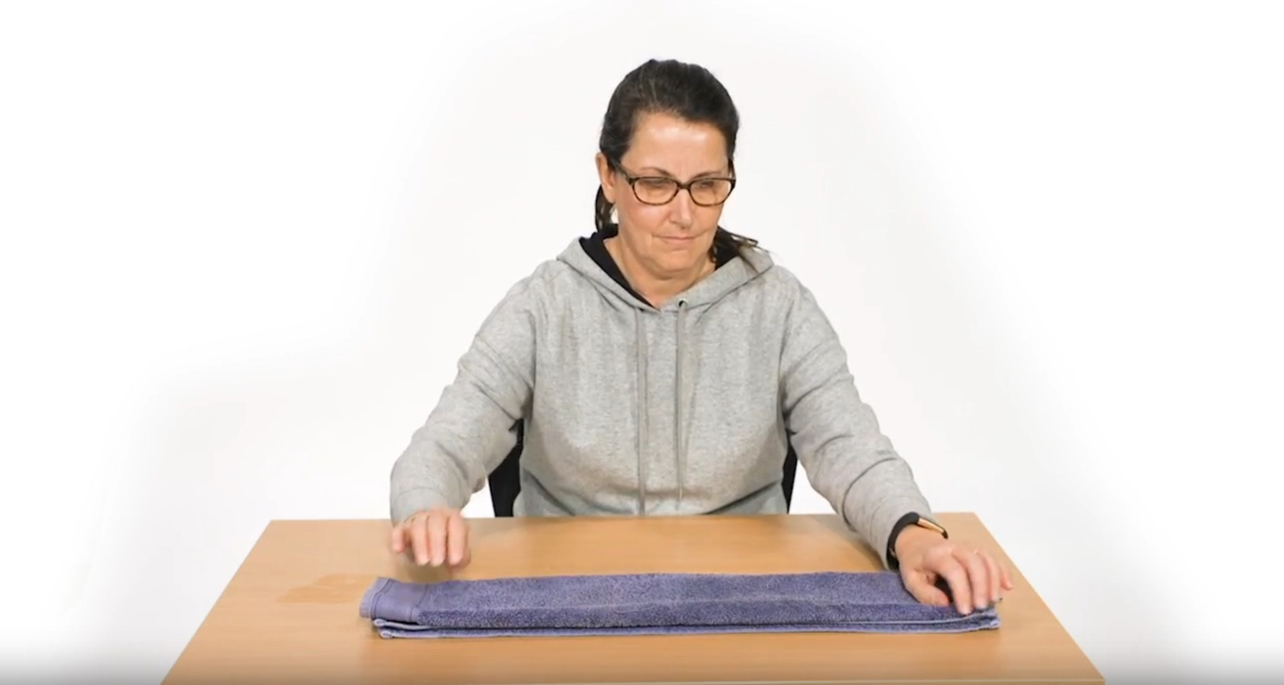

1. Figure 30 above

2. 30_Laundry

3. Patient seated at desk with both arms relaxed, with a small towel which they slowly fold into a rectangle.

4. 30

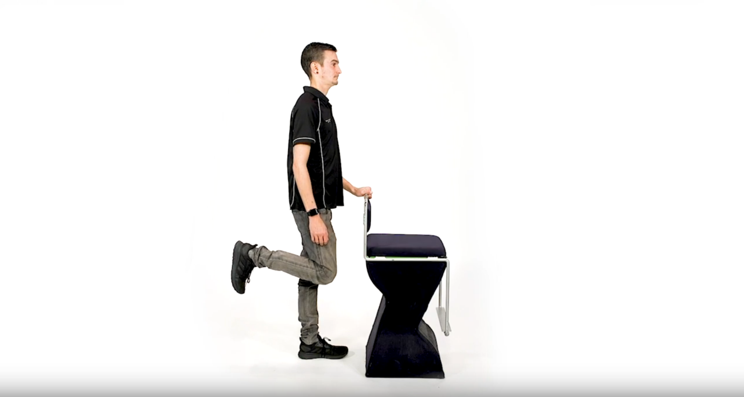

1. Figure 31 above

2. 31_SingleLimbStance

3. Patient standing behind a chair, resting one hand on it. Slowly, raises the opposite leg to 90 degrees in a backwards kick motion. Repeats for opposite side.

4. 31

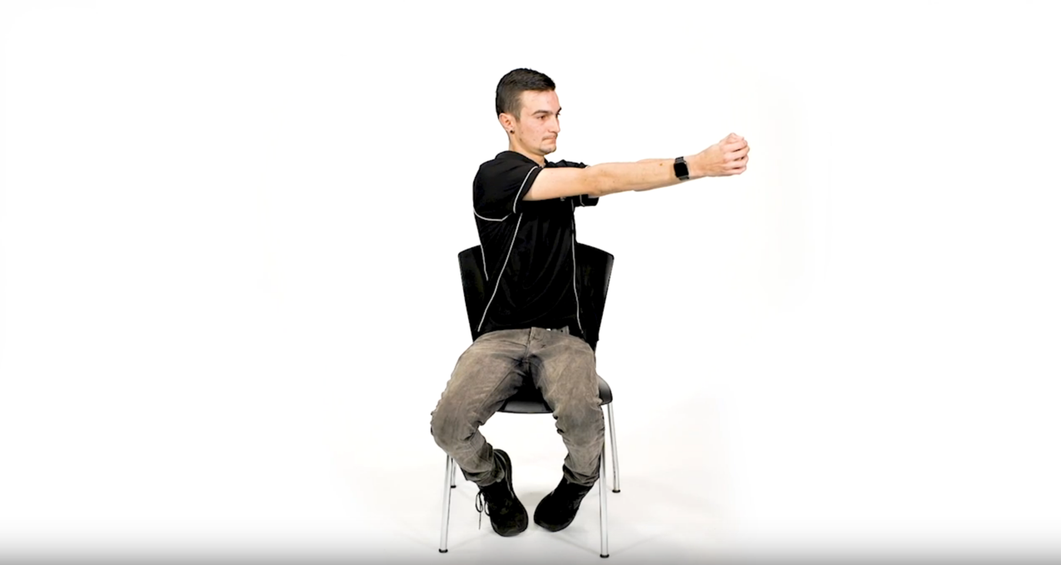

1. Figure 32 above

2. 32_TummyTwists

3. Patient seated on a chair, both arms raised to the chest, hands clasped together. Keeping the head aligned with arm direction, and feet braced to floor, patient slowly twists arms from left to right and back again.

4. 32